2021 Golf Marathon Sponsorship Opportunities
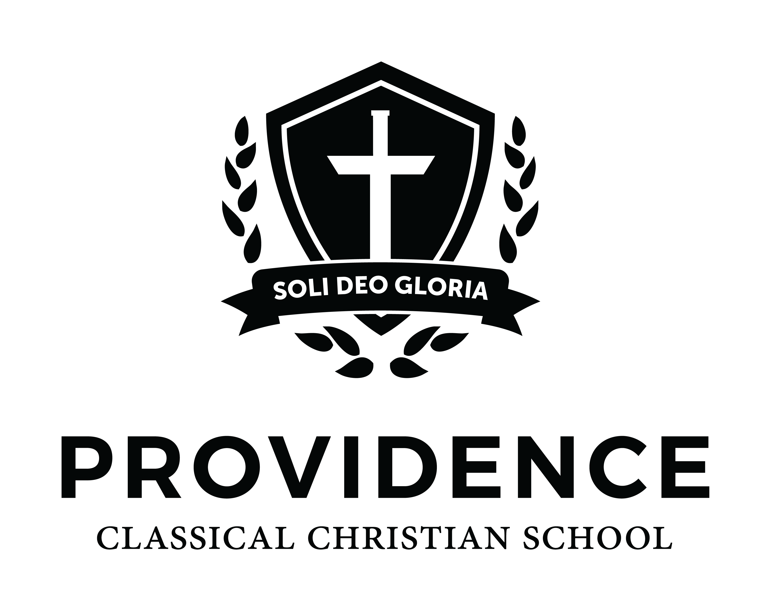

Event Sponsor - $2,500
- Golf Marathon name add of “Sponsored by….”
- Headline space on Event Banner
- Corporate Signage and recognition at Awards BBQ
- Team entry of four players (If any of the golfers are a PCCS parent, the fee will be different)
- Opportunity to supply a signature item featuring your company logo for the appreciation bag
- Recognition from Master of Ceremonies at Awards BBQ
- Recognition on Providence website and weekly parent communication

Course Sponsor - $2,000
- Name add of “Our Course Sponsored by….”
- Second space on Event Banner
- Corporate Signage and recognition at Awards BBQ
- Team entry of four players (If any of the golfers are a PCCS parent, the fee will be different)
- Opportunity to supply a signature item featuring your company logo for the appreciation bag
- Recognition from Master of Ceremonies at Awards BBQ
- Recognition on Providence website and weekly parent communication

Food and Gift Sponsor - $1,000
- Corporate Signage and recognition at Awards BBQ and on the course
- Team entry of two (non-PCCS parent) players. Or $250/$500 can be designated toward a parent player.
- Opportunity to supply a signature item featuring your company logo for the appreciation bag
- Recognition on Providence website and weekly parent communication

Awards and Prize Sponsor - $1,000
- Corporate Signage and recognition at Awards BBQ and on the course
- Team entry of two (non-PCCS parent) players. Or $250/$500 can be designated toward a parent player.
- Opportunity to supply a signature item featuring your company logo for the appreciation bag
- Recognition on Providence website and weekly parent communication

Hole-In-One Sponsor (18th hole only) - $500 - Reserved
- Corporate Signage on the 18th Hole, Tee Box, and recognition at Awards BBQ
- Name on sponsorship of the $20,000 cash Hole-in-One Challenge board
- Opportunity to supply a signature item featuring your company logo for the appreciation bag
- Recognition on Providence website and weekly parent communication

Putting Contest Sponsor (Clubhouse Green) - $500
- Corporate Signage at the Clubhouse and recognition at Awards BBQ
- Opportunity to supply a signature item featuring your company logo for the appreciation bag
- Recognition on Providence website and weekly parent communication

Hole Sponsor (1-17) - $250
- Corporate Signage on the Hole of your choice at the Tee Box, and recognition at Awards BBQ
- Opportunity to supply a signature item featuring your company logo for the appreciation bag or give away at the hole
- Recognition on Providence website and weekly parent communication

